Unit 2Critical listening and music composition
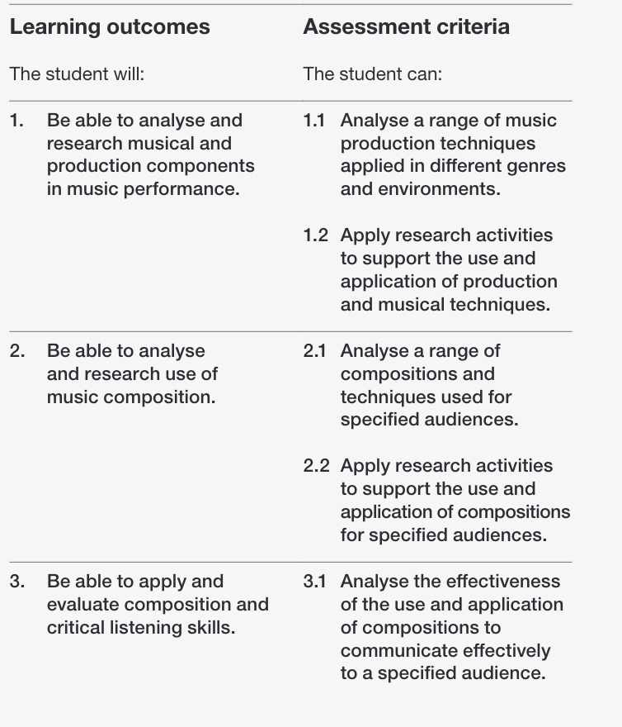

Unit 4
Critical and contextual awareness for music performance and production
