HEALTH AND SAFETY IN THE STUDIO TEST

1a) Provide two examples of how a trip hazard can be caused when you are in a studio.

1b) How can these hazards be resolved/reduced?

2) What do you suggest to reduce/resolve hearing damage in the studio?

3a) What could happen when there is a lot of electronic equipment in one space?

3b) How can this hazard be resolved/reduced?

4a) What could happen if you take food and drink into a recording?

4b) How can this hazard be resolved/reduced?

5a) What are the hazards of using a computer for long periods of time?

5b) How can these hazards be resolved/reduced?

6) The recommended noise level should not exceed how many Decibels?

7) What 2 pieces of information is it handy to know regarding electrical equipment?

8) What is the correct fuse rating for a 300watt guitar amp?

9) What is the correct fuse rating for an 950watt active speaker?

10) Provide 2 examples of what you should NEVER do when a fuse has blown.

11) If an extension cable is too short for application what should you NEVER do?

12) From the following information taken from 2 guitar amps, workout the wattage for each. Show your working out.

- 3amp 230 Volts

- 13amp 110 Volts

14) Please correctly label the following diagram

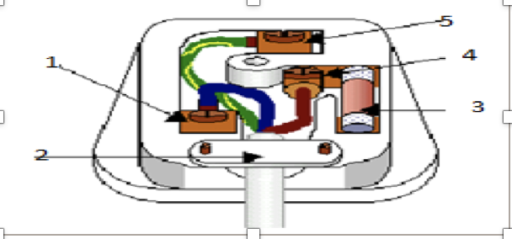

1.
2.
3.
4.
5.

